**Address:**

To: Dr. Christopher Peters and Mr. David Cinciruk

From: Philip Mak and Sancheet Hoque

Date 4/4/2019

Re: Lab 1 - Equipment Automation

**Introduction:**

The purpose of Lab 1 is to learn how to automate the digital multimeter (DMM), arbitrary waveform generator (AWG), and oscilloscope via Matlab or Python using USB commands. The group will gather a few points manually and then automate a large portion of data for each lab instrument in order to see if the automated data is similar to manually collected data. In the chosen programming language, students will apply linear regression techniques to the collected data.

**Method/Analysis**

For the first part, 1A, students setup a basic circuit involving the the DMM, AWG, and a 2k resistor. Current was measured through the resistor as students performed a voltage sweep from 0 to 10 Volts in 1 Volt increments, recording the resultant currents and calculating the resistance through Ohm’s Law. The resistor itself had a resistance of 1977 ohms, while the calculated resistance based on Ohm’s Law of V=IR, knowing voltage and current, was 2038 ohms.

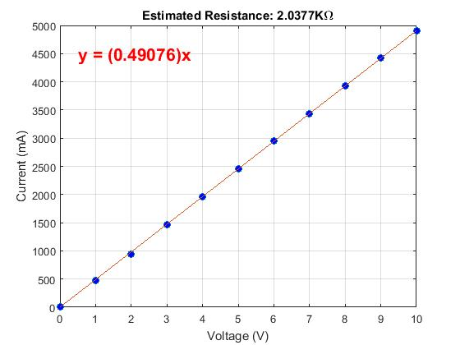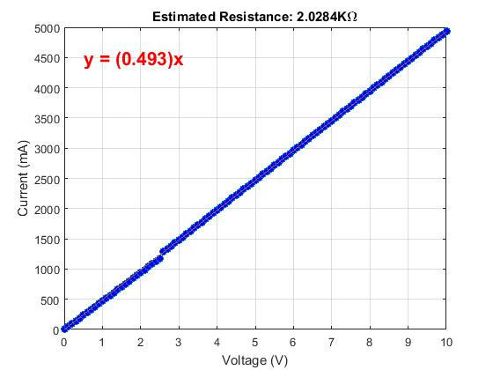

Figure I : Graph of Manual (Left) and Automated (Right) Resistance Estimation

For part 1B, the same sweep was performed via automation with a higher resolution for Voltage. Students obtained the specific address for each of the equipment and utilized the code provided in the lab package. The code used the VISA-USB object for the hardware to software connection. The calculated resistance for the automated testing was 2028 ohms, closer than the manual measurements. In the graph of the automated estimation, there is a jump at 2.5V. This happens due to the DMM switching circuits which causes an error.

For part 1C, the oscilloscope and AWG were used to measure the on-time and frequency of a periodic pulse manually with cursors on the oscilloscope. An automatic retrieval of the frequency was done via SCPI commands with 25 pulses in steps of 5% duty cycle from 20%, to 80%, and then back to 20%. The 25 on-time values were calculated by multiplying the duty cycle by the period. These 25 values vs duty cycle were used to plot the theoretical line in Figure II. The measured line (Right) was plotted in a similar fashion except the number of points that were considered high was multiplied by dt to obtain the on-time. The left plot on-times were calculated by multiple the measured frequency by the duty cycle.

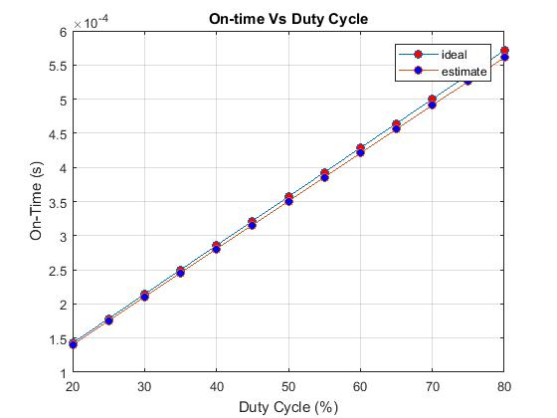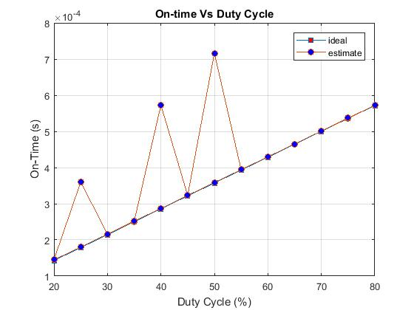

Figure II : Estimated and Ideal On-Time vs Duty Cycle using Measured Frequency (Left) and dt (Right)

**Discussion and Conclusion**

Automation of lab equipment removes the human element from the tedious measuring process. This ideally makes all operations more accurate and precise without the slip of human error. Regarding potential changes to the operation, the explanation on duty cycle calculation can be revised for clarity. In Figure II, the right graph shows spikes in on-time as it goes from 20-80-20% duty cycle. The reason there are spikes lies within the data set used, as they had more than one on-time